

About BMJ Best Practice
BMJ Best Practice is a clinical decision-support tool that quickly and accurately connects healthcare professionals to the latest clinical information whenever and wherever they need it. It provides step-by-step guidance on diagnosis, prognosis, treatment, and prevention, updated daily using robust evidence-based methodology and expert opinion. It is the only point-of-care tool to support the management of single conditions and patients with more complex comorbidities. It will help Jefferson healthcare professionals treat the whole patient.

About the Comorbidities Manager
A key feature of BMJ Best Practice, the Comorbidities Manager, prompts you to consider a patient’s comorbidities when accessing treatment information for acute conditions, such as COPD, diabetes, asthma, and depression. This tailored approach provides you with initial management plans based on your patient's unique combination of conditions, the latest US guidelines, and expert opinion so you can treat the whole patient and not just the acute condition for which they sought help.
Managing patients with complex conditions can be challenging. Watch this video to see how the treatment algorithm changes when a patient’s comorbidities are added. The number of comorbidities or considerations you can add is unlimited.
​​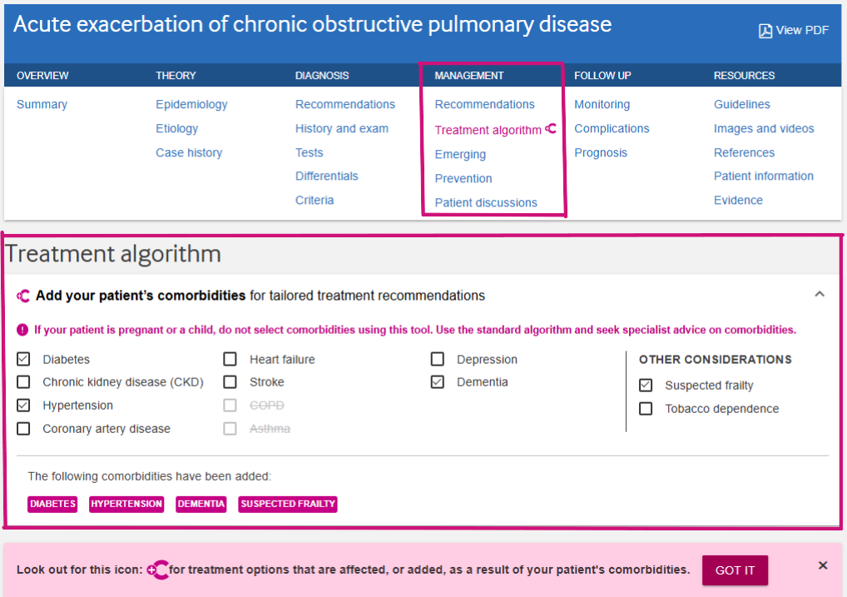
Example of the Comorbidities Manager on a topic page.

Access
BMJ Best Practice is now available to the entire multi-disciplinary healthcare team at the Jefferson Health System. Once logged into the Jefferson Health wifi network, you can access BMJ Best Practice at bestpractice.bmj.com.
FAQ
How do I create a user profile in BMJ Best Practice?
Follow these three steps to create a user profile that gives you access anytime, anywhere:
- Connect to the Jefferson Health wifi network and visit bestpractice.bmj.com
- Create a user profile: On your first visit, you will be prompted to create a user profile. If you’re already using the tool, you can also select ‘My Profile’ and follow the instructions to set up a free user profile, including verifying your account for security purposes.
- Download the app by visiting our app information page and selecting the relevant app store. You can also search for ‘BMJ Best Practice’ directly from the App Store or Google Play. Once prompted, enter your user profile login details to complete the download.

Do I need to register to use BMJ Best Practice?
No. Once logged into the Jefferson Health network, you can access BMJ Best Practice.


Why should I create a user profile?
A BMJ Best Practice account provides a variety of benefits, including:
- The option to access BMJ Best Practice anytime, anywhere, on both the website and app.
- Automatically track and earn CME/CPD credits. Personalized certificates will help you demonstrate your learning.
- Instant access to our highly rated BMJ Best Practice app
  - Offline access--App will update once you’re connected to wifi
  - Share links
  - Save searches and bookmark pages

How do I download the BMJ Best Practice Mobile app?
Search for “BMJ Best Practice” from the Apple App Store or Google Play Store and download. 
Sign in from your device and enter your user profile credentials. Once logged in, the app is authenticated for one year, after which you will be prompted to re-authenticate. CME credits and recently viewed topics will be seamlessly synced between the app and your desktop computer.
Note: You must have created a user profile to access the app.

Who accredits BMJ Best Practice?
BMJ Best Practice is accredited globally. AMA PRA Category 1&2 credits are available for Physicians, Nurses, Pharmacists, and Physician Associates.
- View the complete list of accrediting bodies
- Review CME/CPD-specific FAQ

How do I earn CME?

First, you will need to create a user profile. Once logged in, your time spent reading topics will be automatically tracked. Search for a topic of interest and click on the entry. As you read, you will notice the tool automatically adds 0.25 CMEs to the CME tracker on the top right.

How do I claim CME?
- Login to the BMJ Best Practice website and click the CME/CPD button at the top right-hand corner of your screen.
- Select the browsing activity you would like to claim.
- Record the impact of this activity and add your reflections to the free text box at the bottom of the form.
- Click on your preferred accrediting body and follow the prompts or click on “Save & Download” to submit them at a later date.

How do I find the latest updates?
Recent updates are visible on the homepage under “What’s new.”
Access “Clinical updates” to see what’s been changed and review critical “Important practice-changing updates.” Updates can also be browsed by specialty.
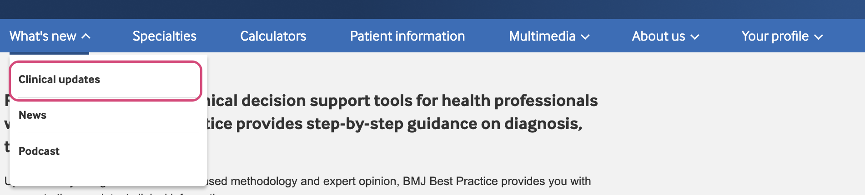
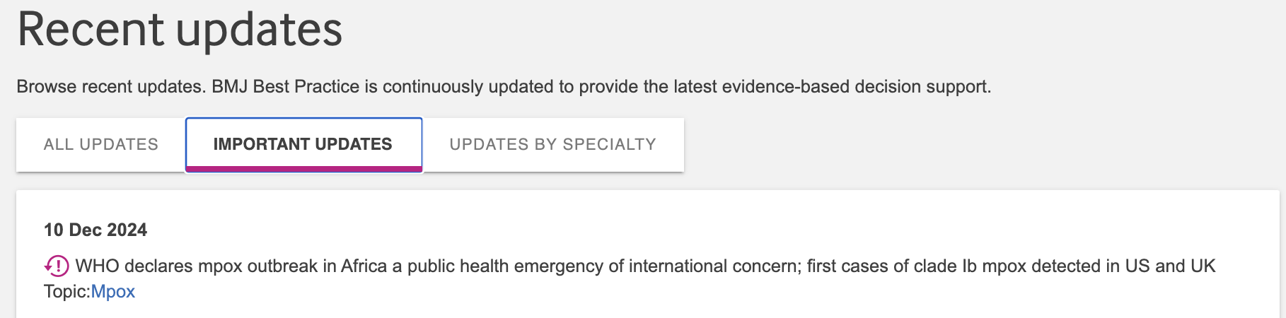Example of the “What’s New” area filtered to “important updates”
BMJ Best Practice also tracks topics you recently viewed and notifies you if an important update has been made to a topic you’ve viewed during the past six months.

The app's ‘bookmarks’ feature allows you to add shortcuts to commonly viewed topics, calculators and patient leaflets.

What are the benefits of BMJ Best Practice?
The intuitive design helps support real-life clinical demands. It is based on the clinical workflow, delivering fast and easy access to the latest information for making diagnosis and treatment decisions at the point of care.
Step-by-step guidance on diagnosis, prognosis, treatment, and prevention is updated daily using robust evidence-based methodology and expert opinion.
Review BMJ Best Practice features at-a-glance

Notable features in BMJ Best Practice
- A highly rated app grants access to a wealth of information even when you’re offline.
- Clinically-focused content: BMJ Best Practice curates information uniquely designed for real-world clinical scenarios, covering assessments and condition topics. Key features include a Comorbidities Manager, a unique treatment algorithm and guidance on tests to avoid, GRADE tables, and a comprehensive evidence layer reinforced by Cochrane Clinical Answers. Additional resources include clinical calculators, multimedia content, brief procedural videos, an Evidence-Based Medicine Toolkit, and more.
- Step-by-step approach: Navigate diagnosis, prognosis, treatment, and prevention with clear and concise guidance.
- The Comorbidities Manager considers a patient’s comorbidities when accessing treatment information for acute conditions such as COPD, diabetes, asthma, and depression. This tailored approach provides initial management plans based on your patient’s unique combination of conditions, the latest US guidelines, and expert opinion. This enables you to treat the whole patient, not just the acute condition for which they sought help.
- A trusted perspective that is both evidence-based and expert-informed. Nearly 100,000 references help reinforce the knowledge shared by over 1,600 practicing US-based authors & international specialists. A feedback button allows direct communication with the Editorial team.
- Currency: Content is updated daily, and every topic includes a date stamp, ensuring you have access to the latest research available. A consistent layout makes information easy to find.
- Jefferson-specific guidance can be viewed alongside local and international guidelines when applicable.
- Extensive content coverage:
- Over 30 specialties
- Summary-level drug information. Connects seamlessly with AHFS and Micromedex drug formularies.
- Practice-changing updates are shared upon release and highlighted with visual alerts.
Visit the BMJ Best Practice website to review a full list of product features. Select your discipline under ‘Who we help’ for a list of the features most relevant to your role.

How does BMJ Best Practice remain current?
BMJ Best Practice is updated daily. An evidence team collaborates with over 1,600 international expert authors and over 2,500 peer reviewers to ensure that users always have the latest practical, evidence-based information for the clinical setting.
Robust evidence-based methodology and expert opinion are reviewed continuously to ensure the content provides access to the best available information possible, in line with our robust evidence processes that include:
- Systematic searches for high-quality new and updated international guidelines
- Continuous in-house scanning and triaging of drug alerts
- Daily monitoring and triaging of user/customer feedback by our Senior Clinical Editor
- External peer review of all new topics by at least two leading international experts and practicing clinicians
- Internal peer review and sign-off for all content by in-house pharmacist and clinical editors
- Updated daily, together with information about the changes made

When should you use BMJ Best Practice?
- Clinical decision-making at the point of care: Access step-by-step guidance on diagnosis, prognosis, and treatment options
- Managing patients with multiple chronic conditions: Consider your patient's comorbidities alongside their acute conditions to create a tailored treatment plan
- Staying current with best practices: Ensure you incorporate the latest research findings into your daily routine. Use the “What’s New” section to quickly browse updates by importance or specialty.
- Developing differential diagnoses: Considering multiple possibilities? BMJ Best Practice can guide your diagnostic thought process
- Researching treatment options: Explore different treatment options and their supporting evidence. Summaries include links to relevant guidelines and references for more in-depth information

Does the tool provide expert opinion to add context to medical knowledge and research findings?
BMJ Best Practice blends the best available evidence with clinical expertise. To enhance and clarify this evidence, there are established advisory boards, including a dedicated US expert panel. These representatives, composed of renowned experts in their respective fields, guide in situations where robust evidence may be limited. The names, affiliations, and conflict of interest statements of these experts are listed on the summary page for each topic.
The robust evidence process includes the following:
- Routine scheduled topic updates.
- Surveillance for new practice-changing evidence and drug alerts.
- Quality assurance


How do I give feedback while using the product?
Your opinion matters! On the bottom right-hand corner of every page, you will find a ‘feedback’ button. Please use this tool to provide your input and indicate if you want us to contact you directly. You will also find BMJ Group's contact information if you
need immediate assistance.

Training and support
Learn about the power of BMJ Best Practice, its speed to answer, and how to optimize its use from the experts. Register to join an interactive training session
Watch a clinical walk-through with Dr. Comfort King (16 minutes)
Watch an overview video of BMJ Best Practice (4 minutes)
See the Comorbidities Manager in action (3 minutes)
BMJ Group has dedicated team members available to answer questions or host impromptu demonstrations for Jefferson Health associates:
- Dr. Comfort King (Clinical Lead), cking@bmj.com
- Denise De La Rosa, ddelarosa@bmj.com

Additional resources
Getting started guide

How to: Add your organization’s local guidance

BMJ Best Practice podcast—Interviews with clinical experts aimed at healthcare professionals interested in keeping up-to-date on the latest scientific developments, evidence-based medicine, and guidelines.

Frequently asked questions
- Features
- Evidence
- How to search
- CME/CPD

Administrative support tools—Find relevant tools for usage support, getting started, end-user support guides, and videos.

